1. Insert an M3 not in the circled slot on the gear and fasten an M3 bolt gently into it so that it won’t move.

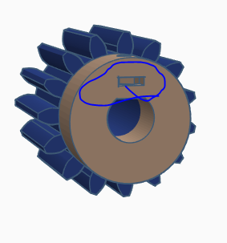

1. Insert the gear over the shaft of the motor. This has to be a tight fit. You may need to use a heat gun, blow drier, or a press.

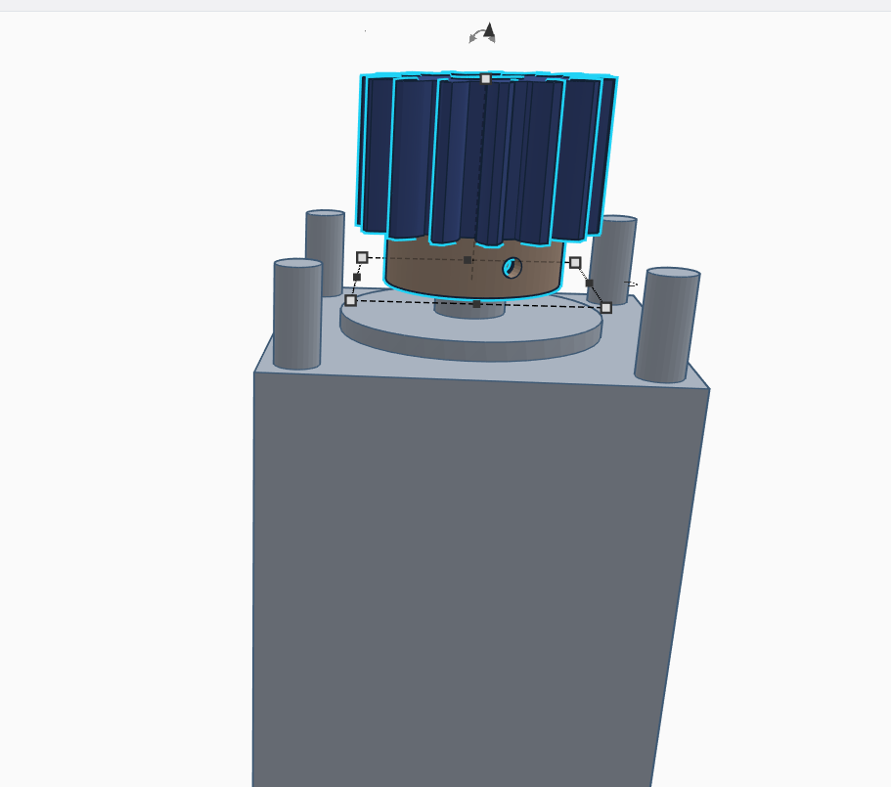

1. Use m4 nuts and bolts for the stepper motor and the motor cage.

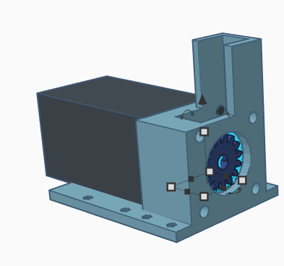

1. Use m2 nuts and bolts to secure the motor cage to the bridge.

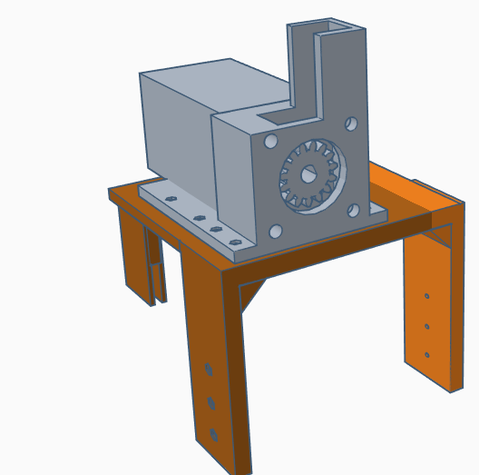

1. Insert an M3 nut in to the rack

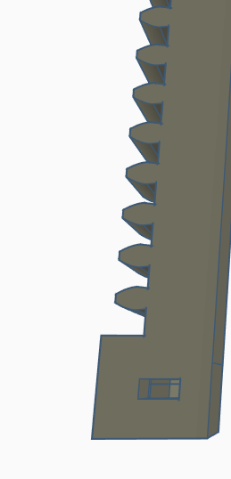

1. Place the rack into the rack base and insert an m3 bolt into the slot.

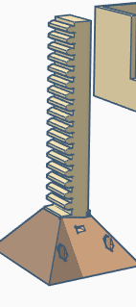

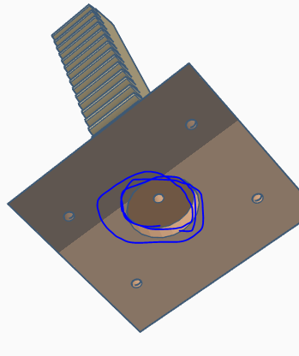

1. Use M3 nuts and bolts to secure the rack base to the plate.

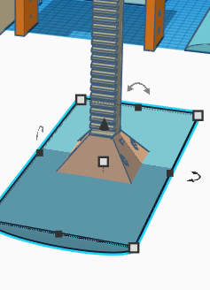

1. Insert the rack through the motor cage

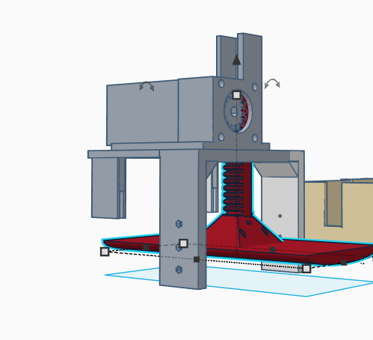

1. Use M3 nuts and bolts to secure the bridge to the vent Box

